Database and Management Systems Internship
Task 1: Database Design & ER Diagram
Daryl Tech & Educational Network (DTEN)
Submitted by: Gifty Lumor Adzo | Student ID: 2526400193 | GCTU

1. Scenario
This project designs a relational database for a Hospital Records Management System. The system tracks patients, doctors, departments, appointments, diagnoses, and prescribed medications, allowing hospital staff to manage patient care records efficiently and accurately.

2. Entities and Attributes
The database consists of six entities. Each entity below is shown with its attributes, data types, and key designations (PK = Primary Key, FK = Foreign Key).

Patient
Attribute | Data Type | Key / Notes
PatientID | INT | Primary Key
FirstName | VARCHAR
LastName | VARCHAR
PhoneNumber | VARCHAR

Doctor
Attribute | Data Type | Key / Notes
DoctorID | INT | Primary Key
FirstName | VARCHAR
LastName | VARCHAR
Specialty | VARCHAR | e.g., Cardiologist
PhoneNumber | VARCHAR
DepartmentID | INT | Foreign Key -> Department

Department
Attribute | Data Type | Key / Notes
DepartmentID | INT | Primary Key
DepartmentName | VARCHAR | e.g., Cardiology, Pediatrics
Location | VARCHAR | e.g., Building / Floor

Appointment
Attribute | Data Type | Key / Notes
AppointmentID | INT | Primary Key
PatientID | INT | Foreign Key -> Patient
DoctorID | INT | Foreign Key -> Doctor
AppointmentDate | DATE
AppointmentTime | TIME
Reason | VARCHAR

Diagnosis
Attribute | Data Type | Key / Notes
DiagnosisID | INT | Primary Key
AppointmentID | INT | Foreign Key -> Appointment
Condition | VARCHAR | e.g., Malaria, Hypertension
DiagnosisDate | DATE

Medication
Attribute | Data Type | Key / Notes
MedicationID | INT | Primary Key
DiagnosisID | INT | Foreign Key -> Diagnosis
DrugName | VARCHAR | e.g., Paracetamol
Dosage | VARCHAR | e.g., 500mg twice daily
DurationDays | INT

3. Entity-Relationship (ER) Diagram
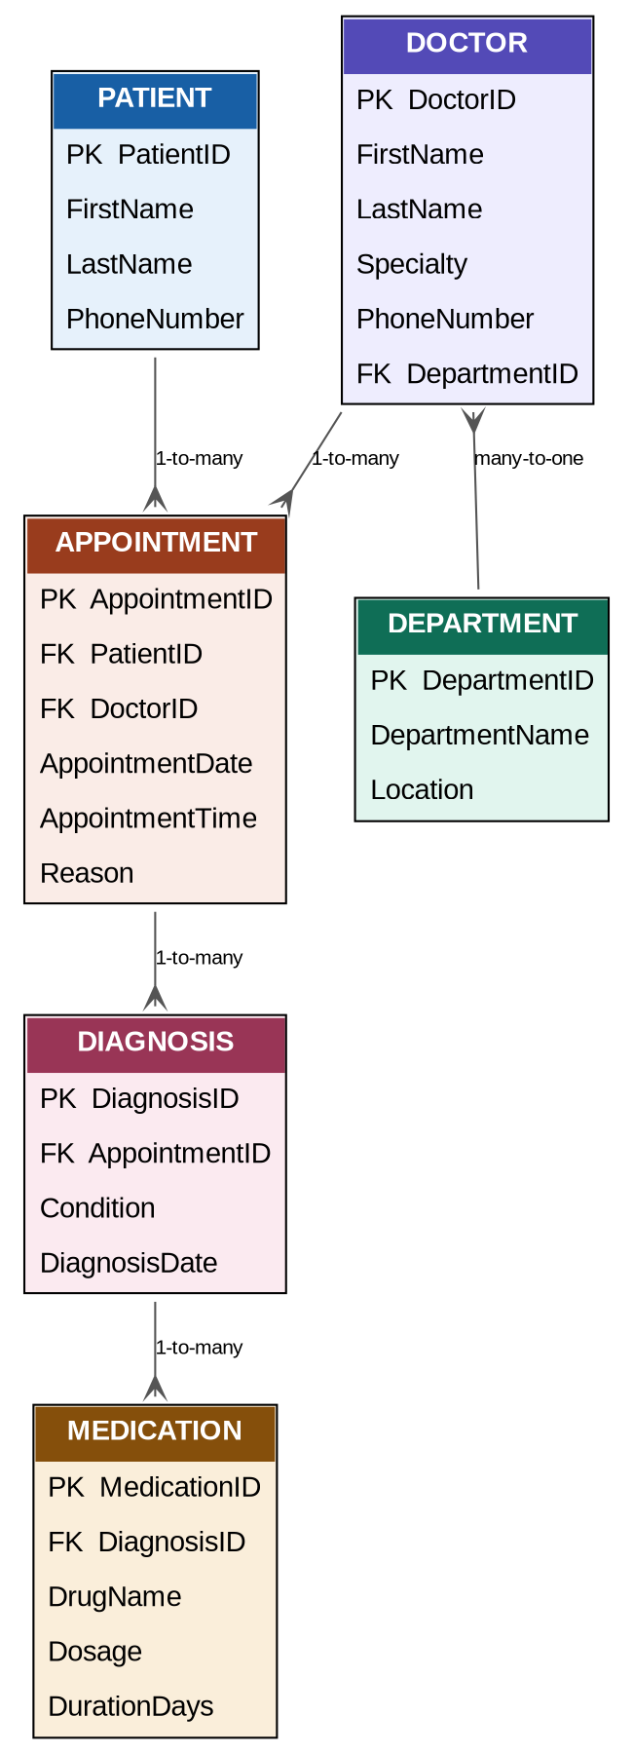

4. Justification of Key Design Decisions
Primary Keys
Each entity has its own single-column numeric Primary Key (e.g., PatientID, DoctorID). Using a dedicated ID rather than a natural attribute like a phone number ensures every record has a stable, unique identifier that never changes, even if a patient's contact details are updated.
Foreign Keys
Foreign keys link related tables instead of repeating data. For example, Doctor stores a DepartmentID rather than writing the department name directly into every doctor's row. This means the department name is stored once, in the Department table, and if it ever changes, only one row needs to be updated instead of every doctor's record. The same logic applies to Appointment linking to Patient and Doctor, Diagnosis linking to Appointment, and Medication linking to Diagnosis.
Normalization (3NF)
The schema is normalized to Third Normal Form (3NF) to eliminate data redundancy and prevent update anomalies:
- 1NF: Every attribute holds a single, atomic value (e.g., FirstName and LastName are stored separately rather than one combined "Name" field).
- 2NF: Every non-key attribute depends on the whole primary key. Since all tables use a single-column primary key, there are no partial dependencies.
- 3NF: No non-key attribute depends on another non-key attribute. For example, DepartmentName is not stored in the Doctor table because it depends on DepartmentID, not on DoctorID directly — it belongs in its own Department table.
This design keeps the database consistent, avoids repeated data, and makes it easy to update information (such as a department name or a drug's dosage guideline) in exactly one place.

